**CHAPTER 1**

# INTRODUCTION

**1.1 About the Project:**

In this project we have three rods and we can choose number of disks from 3 to 10. We have seven options after selecting number of disks.

1. First option is for lightning which can be on or off.
2. Second option is move camera which allows, the user to move the camera to experiment with perspective viewing.
3. Third option is animation which can be on or off.
4. Fourth option is background color where we can set the color of the background to 5 colors or we can set it to random which changes to random color on every click.
5. Fifth option is solve completely, where the disk move automatically and the problem is solved.
6. Sixth option is Reset which resets the disks back to original positions.
7. Seventh option is exit.

It also shows the number of moves. Movement of every disk is shown with disk number and rod.

## 1.2 Problem Statement:

The Tower of Hanoi is a simple mathematical puzzle often employed for the assessment of problem-solving and in the evaluation of frontal lobe deficits. The task allows researchers to observe the participant’s moves and problem-solving ability, which reflect the individual’s ability to solve simple real-world problems.

**1.3 Objectives:**

Tower of Hanoi is a mathematical puzzle where we have three rods and n disks. The objective of the puzzle is to move the entire stack to another rod, obeying the following simple rules:

1. Only one disk can be moved at a time.
2. Each move consists of taking the upper disk from one of the stacks and placing it on top of another stack i.e. a disk can only be moved if it is the uppermost disk on a stack.
3. No disk may be placed on top of a smaller disk.

**CHAPTER 2**

# SYSTEM REQUIREMENTS

**2.1 Software Requirement:**

* Operating System : Windows 10/XP/Vista
* Language : Open Gl
* Compiler : Dev c++

**2.2 Hardware Requirement:**

* Processor : Intel(R) Core(TM) i3-7100U CPU @ 2.40GHz 2.40 GHz
* Ram: 8.0 GB
* Display : VGA Color Monitor

**CHAPTER 3**

# IMPLEMENTATION

## 3.1 Function / Method Description

This program is implemented using various openGL functions which are shown below.

Various functions used in this program :- ➢

* glutInit() : interaction between the windowing system and OPENGL is initiated. ➢ glutInitDisplayMode() : used when double buffering is required and depth information is required. ➢
* glutCreateWindow() : this opens the OPENGL window and displays the title at top of the window. ➢
* glutInitWindowSize() : specifies the size of the window. ➢
* glutInitWindowPosition() : specifies the position of the window in screen co-ordinates. ➢ glutKeyboardFunc() : handles normal ascii symbols. ➢
* glutSpecialFunc() : handles special keyboard keys. ➢
* glutReshapeFunc() : sets up the callback function for reshaping the window. ➢
* glutIdleFunc() : this handles the processing of the background. ➢
* glutDisplayFunc() : this handles redrawing of the window.➢
* glutMainLoop() : this starts the main loop, it never returns. ➢
* glViewport() : used to set up the viewport. ➢
* glVertex3fv() : used to set up the points or vertices in three dimensions. ➢
* glColor3fv() : used to render color to faces. ➢
* glFlush() : used to flush the pipeline.➢
* glutPostRedisplay() : used to trigger an automatic redrawal of the object. ➢
* glMatrixMode() : used to set up the required mode of the matrix. ➢
* glLoadIdentity() : used to load or initialize to the identity matrix. ➢
* glTranslatef() : used to translate or move the rotation centre from one point to another in three dimensions.
* glRotatef() : used to rotate an object through a specified rotation angle.

## 3.2 RESULTS (Screenshots of the Output)

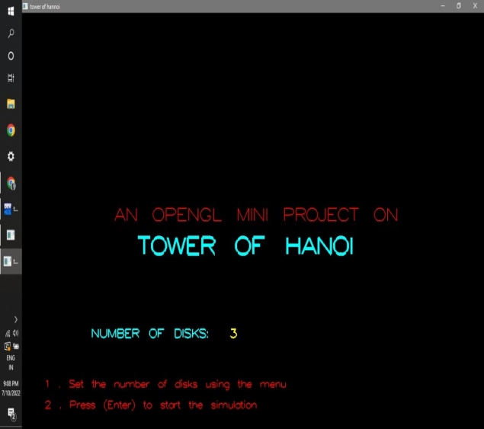 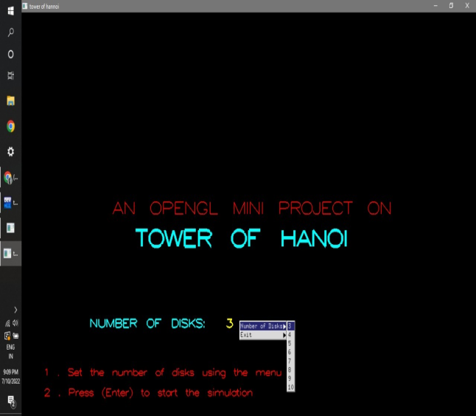

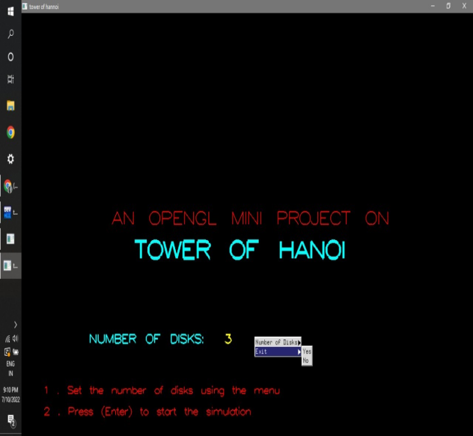 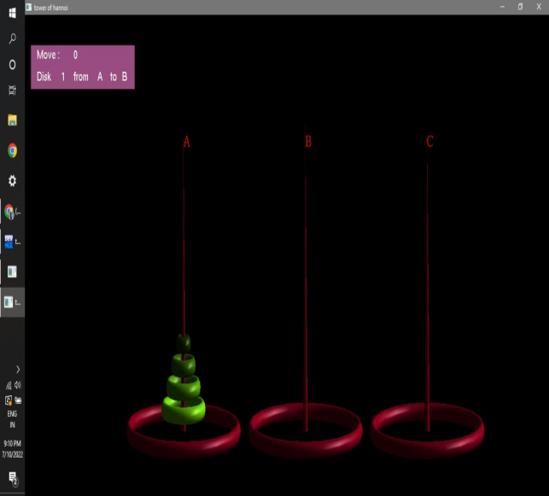

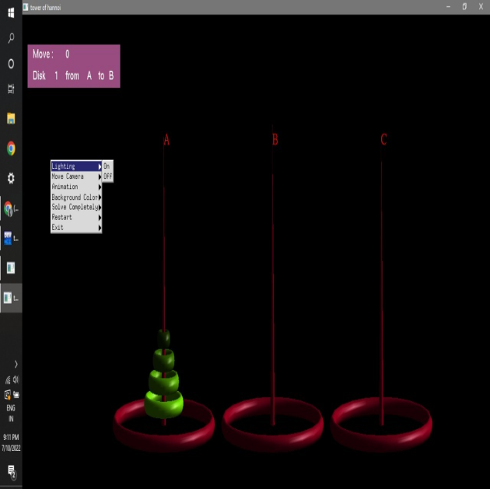 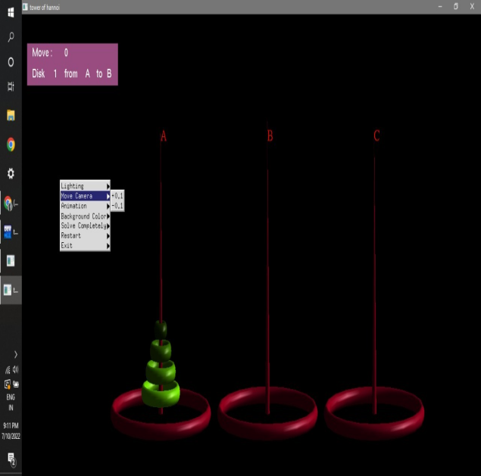

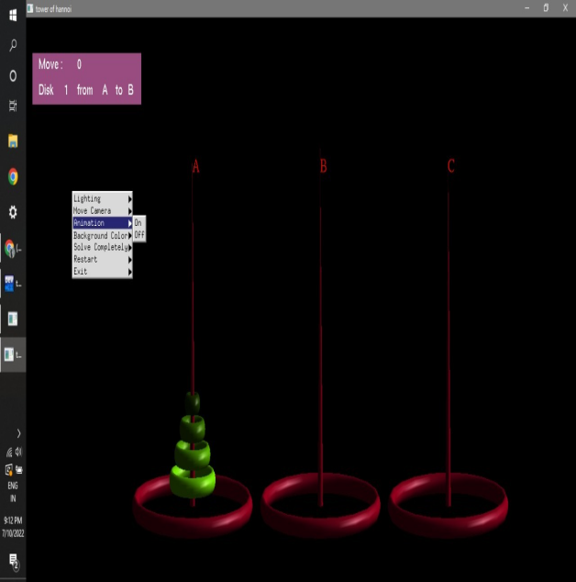 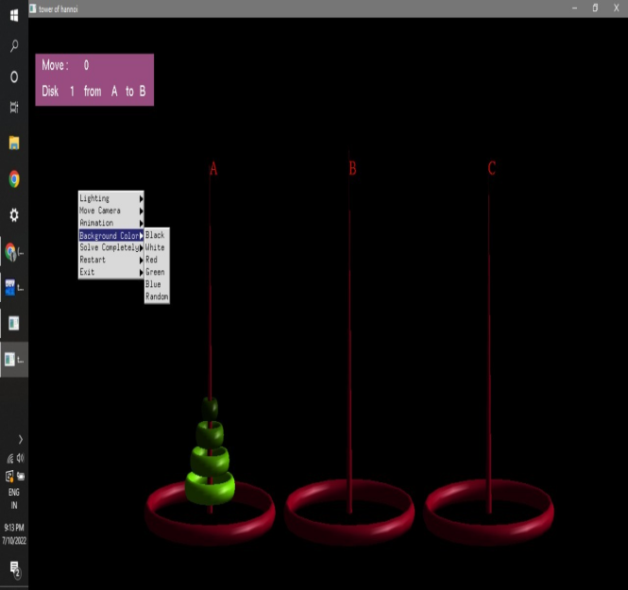

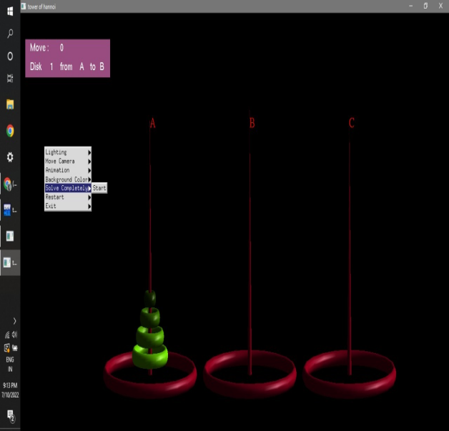 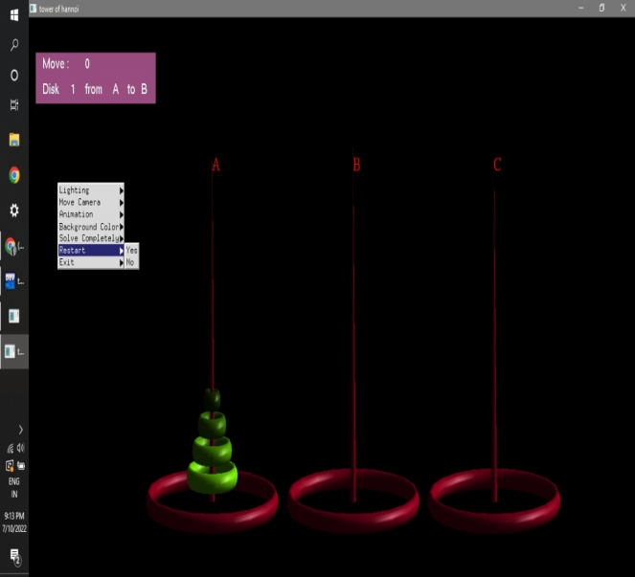

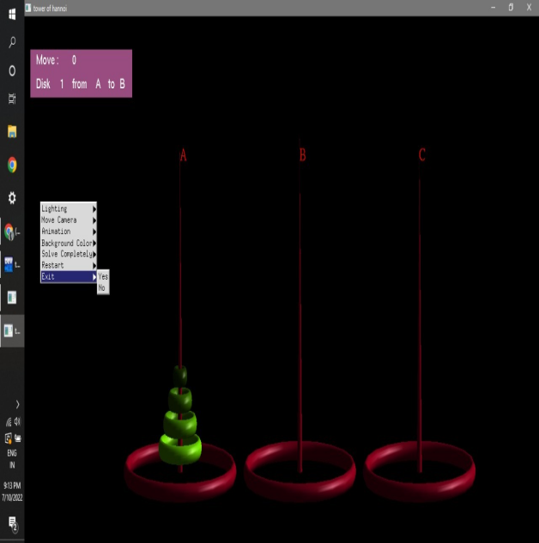 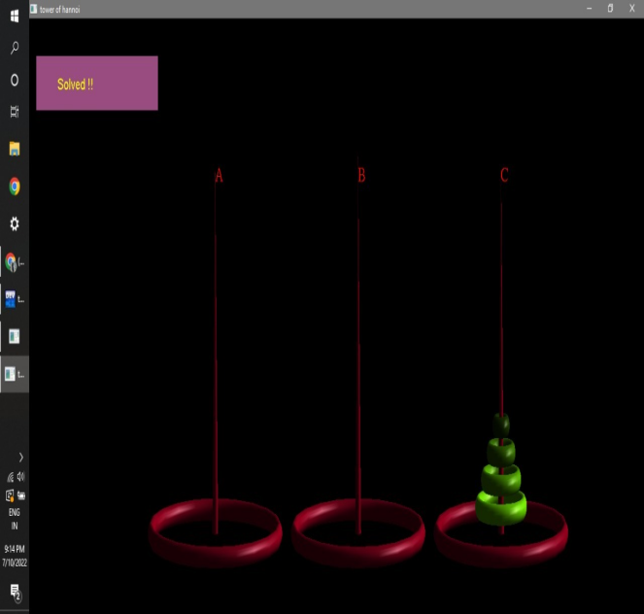

**CHAPTER 4**

# CONCLUSION

It was a wonderful learning experience for us working on this project. This project took us through various phases of project development and gave us real insight into the world of software engineering. It was due to project that we came to know how professional software’s are designed. We enjoyed each and every bit of work put into this project.